|  |  |
| --- | --- |
| **Use Case ID:** | PlantsCare-API02 |
| **Use Case Name:** | Received questions from user. |
| **Area:** | Server |
| **Actor:** | API |
| **Description:** | Received questions from and send it to the chat-bot. |
| **Preconditions:** | The question must be predefined. |
| **Post conditions:** | API return the answer of the selected question. |
| **Triggering Event:** | Clicks ‘send’ button |
| **Main Flow:** | 1-user select pant type.  2-user select a question from the predefined questions.  3-API receive the question. |
| **Alternative Flow:** | If the user select non-predefined plant type or non-predefined question, an error message should appear to him. |

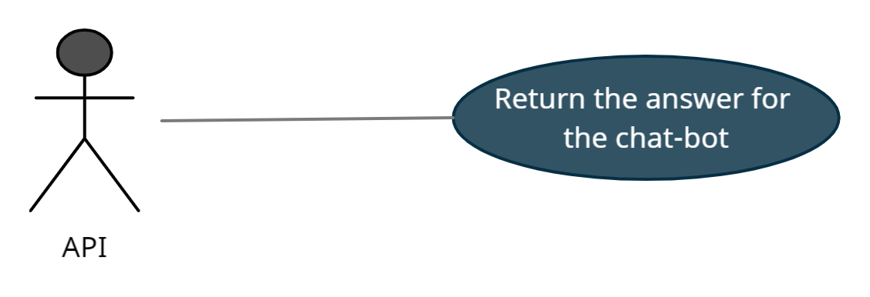

|  |  |
| --- | --- |
| **Use Case ID:** | PlantsCare-API03 |
| **Use Case Name:** | Return the answer of the question. |
| **Area:** | Server |
| **Actor:** | API |
| **Description:** | Return the answer of the selected question from the chat-bot. |
| **Preconditions:** | The question must be predefined. |
| **Post conditions:** | API return the answer of the selected question. |
| **Main Flow:** | 1. API return the answer to the user. |
| **Alternative Flow:** | If the user select non-predefined plant type or non-predefined question, an error message should appear to him. |

